CN7031 - Big Data Analytics
Student ID: 3059676
Name: Mann Shrestha

LAB 3
Step 1: Accessing MySQL shell
Step 2: Show Database and Tables
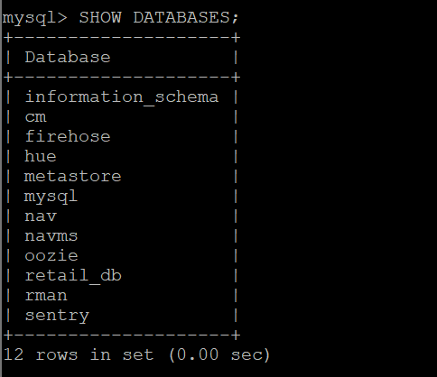
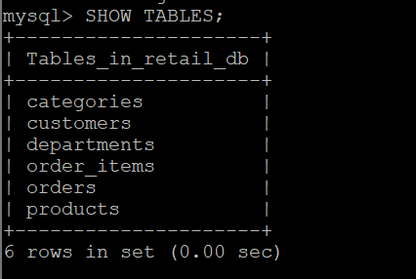
Step 3: Exit from MySQL

Exercise 3: Importing data from MySQL database to Hadoop HDFS
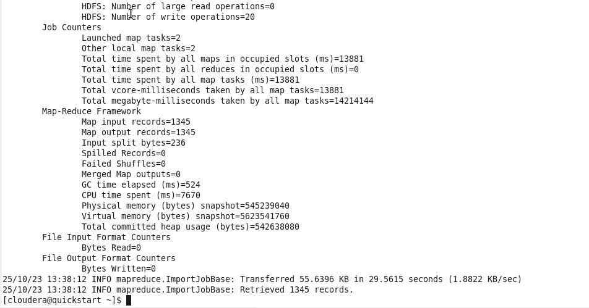
## Verification
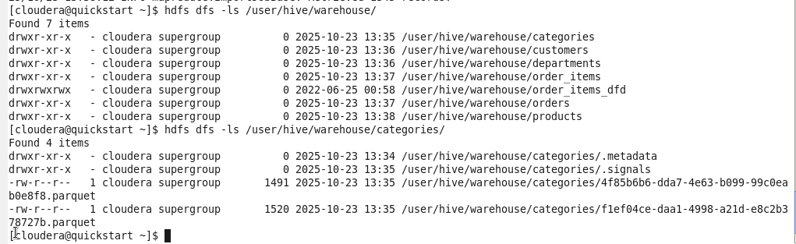
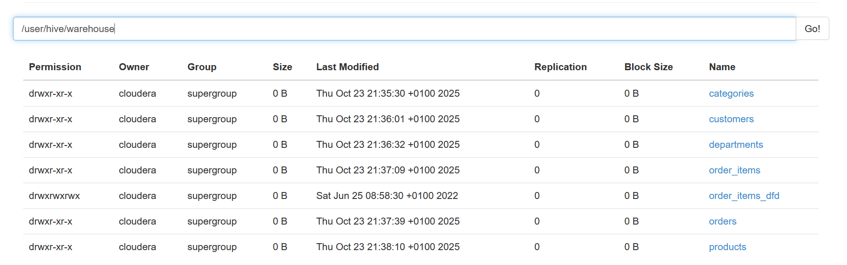

## Exporting data from Hadoop to MySQL
